**The Slave Port**

# Aki Yoshida JA1NLX and Rick Ellison N2AMG

## 1.0 GENERAL

The Slave Port was originally implemented in Logger32 version 3.50.358.

a)The slave port synchronizes a slave receiver/transceiver (of any type) with the main radio frequency and mode and,

b) if “Enable polling of the slave receiver/transceiver....” option is checked then main radio follow slave radio frequency and mode.

## 2.0 Slave Port Setup

To configure the Slave Port, from the Logger32 Setup menu, select the Radio | Slave port configuration menu items.

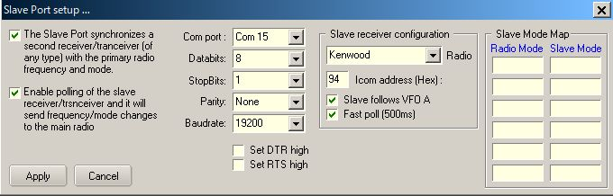

TSP_1

If your transceiver reports both VFO A and VFO B frequency/mode in real time, you may uncheck “Slave follows VFO A” option.  
If you prefer fast polling of slave receiver/transceiver, you may check “Fast poll (500ms)” option. If it is unchecked, polling interva is 1000ms.

The Slave port is opened/closed by right clicking the Radio pane on the Lower Status bar.

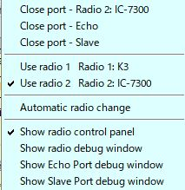

TSP_2

The Slave Port state, open or closed, is shown on the Status bar of the Radio Debug window.

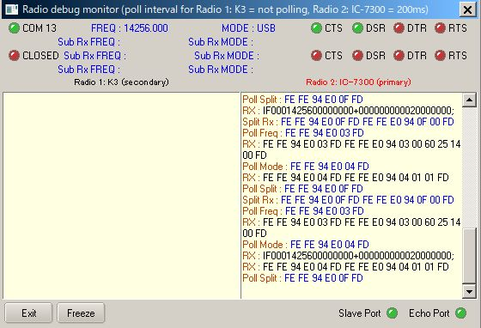

TSP_3

You can see what command is sent to slave radio in Slave Port debug window.

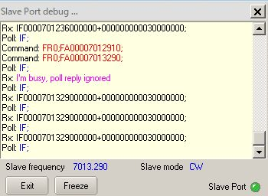

TSP_4

## 3.0 How to command slave receiver or transceiver

Some examples of Slave port settings for various combination of main/slave radios are described below.

### IC-7300 as main radio and another IC-7300 as slave radio In this case slave IC-7300 is connected to COM10. Slave IC-7300 follow main IC-7300 frequency and mode when clicking DX Spot, changing frequency in Logbook Entry Window or sending direct command macro. Main IC-7300 follow slave IC-7300 frequency and mode.

### 

### TSP_5

**FT-920 as main radio and IC-735 as slave radio**

In this case slave IC-735 is connected to COM5.  
Slave IC-735 follow main FT-920 frequency and mode when clicking DX Spot, changing frequency in Logbook Entry Window or direct command macro.　Main FT-920 follow slave IC-735 frequency and Mode.

The right hand side shows the radio Mode conversion.

**Note**: The baud rate is shown as 1200 (factory default). The radio can be set to 9600 with a jumper change.

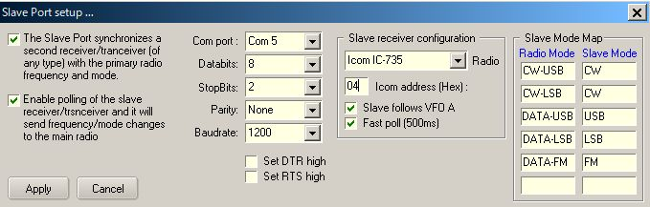

TSP_6

**IC-7300 as main radio and K3 as slave radio**

In this case slave K3 is connected to COM11.

Slave K3 follow main IC-7300 frequency and mode when clicking DX Spot, changing frequency in Logbook Entry Window or sending direct command macro. . Main IC-7300 follow slave K3 frequency and mode.

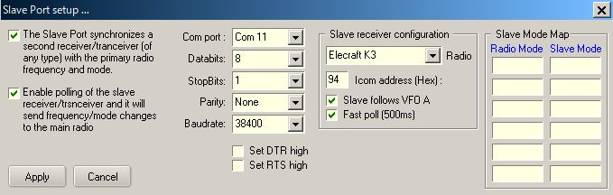

TSP_6A

### 4.0 How to use “cheap” SDR RX as Panadapter

### You will be able to add external Panadapter using “cheap” SDR RX and SDR application. These are controled via Slave Port. We used SDRplay RSP1A as SDR RX, SDRplay SDRuno V1.22 and SDR-Radio SDR Console V3.B2 as SDR application for these testing. These applications can be downloaded at following page.

### <https://www.sdrplay.com/downloads/>

IC-7300 and IC-706MK2G do not report both VFO A and VFO B frequecy/mode in real time, howevwer Logger32 command RSp1A/SDRuno (or SDR Console) frequency and mode when

a. clicking DX spot

b. entering frequency in Logbook Entry Window or changing frequency by mouse wheel

c. rotating IC-7300 VFO knob (VFO A or VFO B)

Changing frequncy and mode in SDRuno (or SDR Console) command Logger32.

Note: Logger32 slave port does not command VFO B in SDRuno. Even if you select VFO B in SDRuno it is back to VFO A when you change frequency/mode in IC-7300

### The basic setup using ICOM IC-7300 and IC706MK2G are explained below.

**Sample configulation diagram**

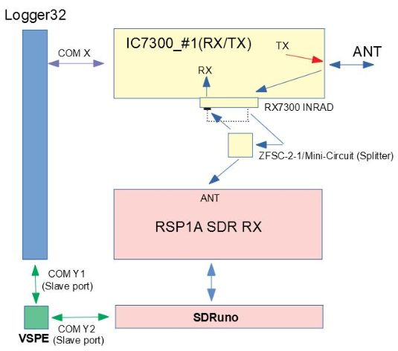

TSP_7

### Sharing Slave Port using VSPE You need to create “Pair” port to shaire Slave Port, one for Logger32 and another for SDRuno. COM 15 and COM 16 are used in the following examples.

**Slave Port setup**

Kenwood should be selected as Radio. Both “The Slave Port synchronize a slave receiver.....” and “Enable polling of the slave receiver.....” option should be checked.

You need to select correct COM port. In this example it is COM 15.

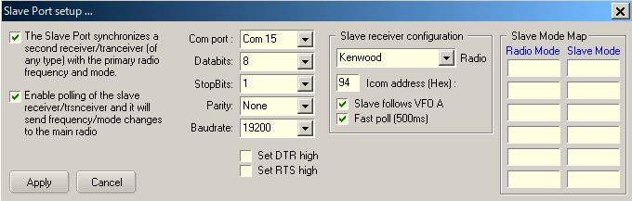

TSP_8

**SDRuno setup**

It will work with dafault setting except COM port. You need to select correct COM port for COM DEVICE. In this example it is COM 16. Details are explained in SDRuno User_Manual.

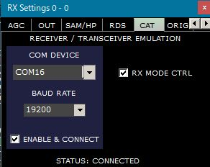

TSP_9

Typical example of SDRuno display.

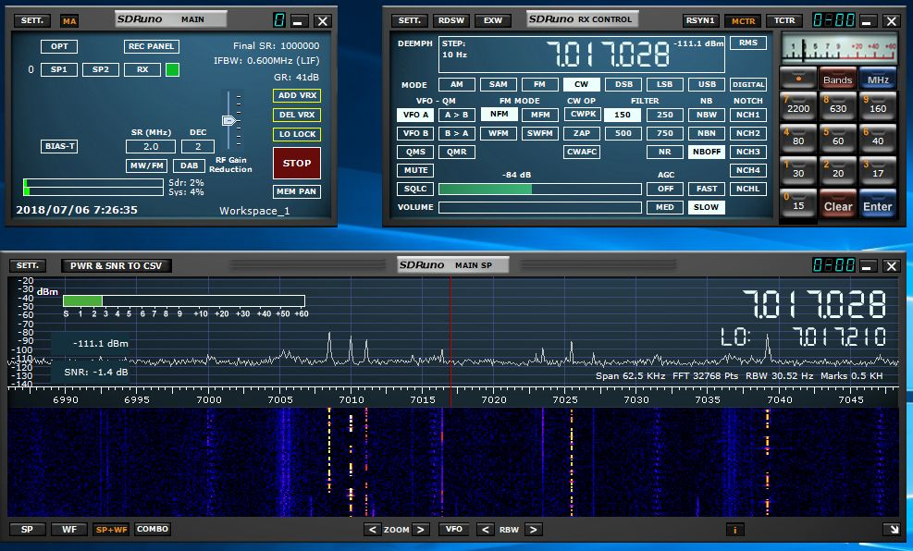

TSP_10

**SDR Console setup**

1. Open the SDRr Console program and Click on Tools.　Click on Options.

2. Click on the Controllers Folder and then select the CAT(Serial Port) folder

3. Scroll the window and find the second half of the Virtual serial port pair that you created earlier. Place

a check in the checkbox for that port and click Ok. (COM16 in this example)

4. On some systems you will need to restart SDR Console for things to work.

5. After opening the Echo Port in Logger32 you may open SDR Console and the radio setup in Logger32

should be able to control the frequency and mode in SDR Console. Clicking in the waterfall or scrolling the

frequency or scrolling in the waterfall will update the radio in Logger32.

One thing to note is the frequency will not be updated in Logger32 until the frequency updates in SDR Console. Ex. When scrolling in the waterfall the frequency will not update until you stop scrolling.

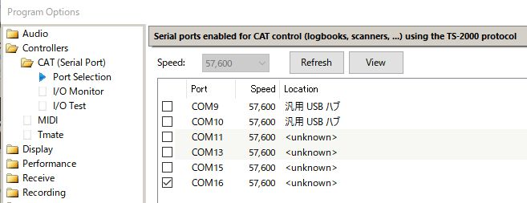

TSP_11

Typical example of SDR Console display.

### 

### TSP_12